# Software Development

Building large pieces of software can be costly and time consuming.

## Elements of Software Development

**Feasibility Study**

- Software development is costly and large projects are not worth starting if they are going to fail. A feasibility study justifies whether a project is worth starting.

- There are a number of reasons a project might fail:  
 - Budget may not be enough to cover the costs of the project.

- It might not be legally feasible.

- It might not be technically feasible.

**Requirements Specification**

- Setting out easily measurable criteria for success of your program.

- The determining of requirements is traditionally done in the requirements elicitation phase which normally culminates in a document called the **requirements specification** which lists each and ever requirement of the final product.

- When the project is signed off it is tested against the requirements specification in what is known as **acceptance testing.**

- This assures the user that the program will be okay for them.

**Testing**

- Should take place continuously through coding process.

- Every time a module of code is written it should be tested to be certain it works. Theoretically if you know all modules work on their own then you only need to test if they work together.

- Testing should include **destructive testing** where testers try to cause a program to crash or behave unexpectedly.

- Testing can be used to show the presence of bugs but never their absence.

- Once the code is free of obvious bugs then the next phase is **alpha testing.** This is where product is used within the company by people who haven’t programmed it.

- The next stage is **beta testing** this is where the software is tested by a small group of users outside the company.

- The final stage is **acceptance testing** when the user tests the program against every requirement in the user specification.

**Documentation**

- Written documents are produced during the software development process.

- Requirements Specification is produced.

- The system design may be documented to allow the programmers to understand what they are doing.

- As the system is built, it may be documented to allow software engineers to be able to understand and maintain it in future.

- As the system is built, it may be documented to allow software engineers to be able to understand and maintain it in future. This is referred to as the **technical documentation.**

- Another important type of documentation is **user documentation.** This is effectively the manual that tells the user how to use the software.

## Methodologies

- To ensure software is delivered on time and budget, different budgets have been developed. These methodologies have been developed.

- These methodologies will have the stages above but take different approaches as to when extent.

**Waterfall Life-Cycle**

- The waterfall cycle is a well-known (and often criticised) development model.

- It consists of a sequence of stages. In its more basic form, each stage is started only if the previous has been completed.

- This only works if each stage is completed perfectly the first time.

- It has been proposed that the system can be improved if you allow iteration between adjacent stages.

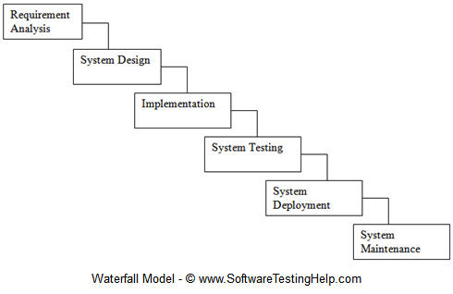

**Advantages and Disadvantages**

- Simple and easy to manage.

- Clear to see if a project is running to schedule as there is an expected output on the end of each stage.

- Carries a lot of risk. It isn’t until the testing stage that the user gets to see something tangible.

- If the requirements have been misunderstood it may be very difficult to rectify mistakes.

- For this reason the waterfall life-cycle is more suited to less complex problems where the requirements are fully understood.

**Rapid Application Development (RAD)**

- Iterative approach to software development. This contrasts with waterfall method which is sequential.

- When part of the project is available, the customer is allowed to evaluate it and confirm it is meeting their requirements.

- Then the project moves forward to develop some more features and the cycle is repeated.

- The emphasis is on developing prototypes **rather than** extensive **requirements documentation.**

- A prototype is a model that represents some features of the overall projects.

There are several kinds of prototypes that the RAD approach can make use of:

**Pilot Prototype**

- Pilot prototypes are used to determine how feasible a design approach is; to test a new technology or a software tool. Pilot software is not intended to be developed further.

- It guides the planning decisions of how the project is to be carried out.

**Modelling Prototype**

- Where pilot prototypes test whether the technology works, modelling prototypes are created to test whether it fits the requirements of the customer.

- The prototype model is demonstrated and discussed with the customer as a communication tool, so both parties agree with what Is required.

- Modelling prototype can be one of two types:

**Throwaway:** once the prototype has been used for discussion or evaluation, the code is discarded. There is no carry-over to future prototypes.

**Evolutionary:** the prototype code is retained and used to develop a more detailed or refined prototype for the next iteration. The prototype is effectively the actual release code as the project develops.

**Advantages and Disadvantages**

- Well suited to projects where requirements aren’t clear from the outset.

- With continuous feedback from the user the final product is likely to have excellent usability.

- As the focus is usability there is often not a focus on how the product works and therefore RAD is not appropriate for projects where efficiency of code is important.

- It is important to have continual contact with the client for RAD so its unsuitable in situations where the user cannot make this commitment.

- RAD doesn’t scale well and thus is less suited to large projects with big teams.

**Spiral Model**

- Software development can involve high amounts of risk. Projects can run out of time, requirements can change and competitors can change and competitors can come out with better alternatives.

- The spiral model is designed to take into account risks within the project.

- By focusing on managing risks this can be dealt with before they become issues.

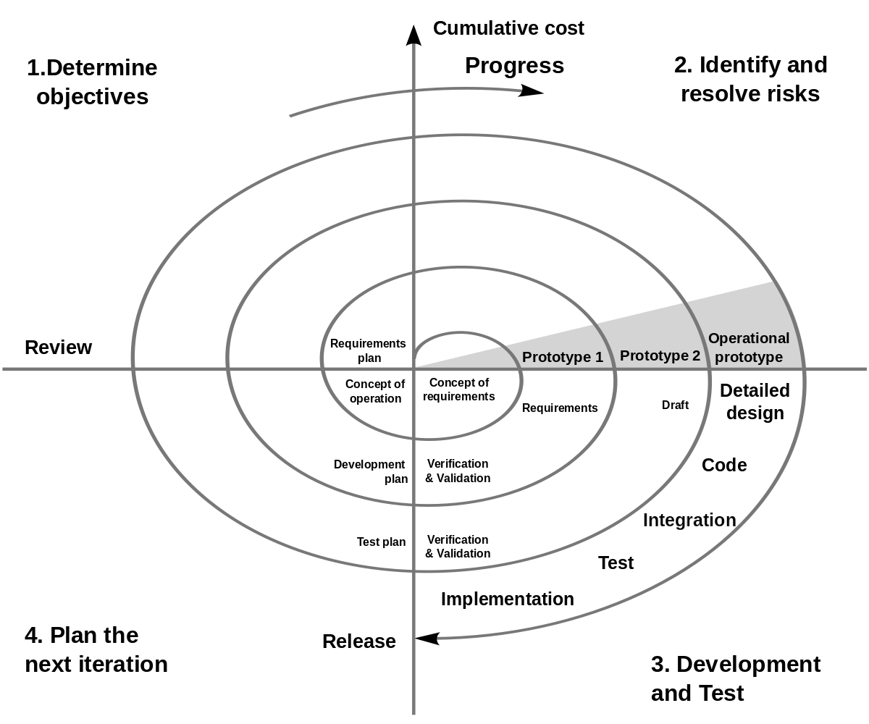

- The model consists of four stages, each forming a quadrant of the spiral. The first stage is to determine the objectives of that rotation of the spiral.

- In the first instance this may be determining the requirements of the project.

- In the next stage the possible risks are identified and alternative options considered, this may involve building a prototype of the system.

- If risks are considered too high at this stage the project may be stopped.

- The third stage allows the project to be worked on to be made and tested.

- After this stage there is a stage to decide what will happen in the next iteration of the spiral.

- There will be a product at the end of each stage of the spiral which can be shown to a user.

**Advantages and Disadvantages**

- The fact that risk is at the heart of the spiral model is its biggest advantage and means it is ideal for projects that are likely to be high risk.

- Large projects in particular tend to be high risk and are thus suitable to this model.

- Risk analysis is in itself a very specialised skill which means the model is only as good as the risk analyst working on it.

- Good risk analysts are expensive which adds cost to the project.

**Agile Programming**

- Agile programming isn’t a single methodology but a group of methods. These methods are designed to cope with changing requirements through producing software in an iterative manner.

- The idea is that in each iteration more functionality is added and the user can choose throughout the project to add more functionality in a future iteration.

- The agile manifesto declares:

1) **Individuals and interactions**: self-organisation and discipline are vital. Working together as a pair is encouraged.

2) **Working Software**: Demonstrating simplified but working versions of the software to the client is considered superior to writing lots of documentation.

3) **Customer Collaboration**: Client cannot define their requirements completely at the start of a project so continuous interaction is encourage to develop more robust requirements as the project matures.

4) **Responding to Change**: Focused on reacting quickly to change and on continuous development.

**Advantages and Disadvantages**

- Functionality can be developed quickly and demonstrated that it will work.

- Gives flexibility to developers.

- Minimal formality and documentation.

- Can handle changing requirements and fixed ones.

- Realistic approach as it takes on board that clients often do not know what they want until they see something in front of them.

- Promotes teamwork and cross training.

- Not good when the modules and features depend on each other in complex ways as it is then difficult to partition the project into smaller parts.

- Due to lack of documentation, can be harder to maintain software in future once the original team has dispersed.

- Depends heavily on customer interaction, so requires a commitment from them.

- Depends on the discipline of the developers to meet deadlines as it is quite light on management.

**Extreme Programming**

- An example of an agile programming methodology.

- A representative user becomes part of the team. They help decide the **user stories** - essentially requirements and decide what tests will be used to show they are properly implemented.

- Iterations are much shorter in XP than in RAD - typically a week.

- While RAD uses prototyping, XP produces a version of the system every time just with limited functionality. The code needs to be good enough in quality to be used in the final product.

- At the start of each iteration the user goes through the **planning game**. This involves deciding what the user stories will be and how the team will divide the work.

- One of the key features is pair programming.

- One programmer **driver** the other is the **navigator.** The driver will use the keyboard while the navigator analyses what has been written.

- The two switch roles regularly ensuring that code works.

- One of the principles of XP is that no programmer should work more than a 40 hour week as code quality will start to decrease.

- Testing is carried out continuously every module is tested as soon as it is made in what is known as **unit testing.**

- Once a module is known to work it is integrated into the main code version so that everyone has access to it.

**Advantages and Disadvantages**

- With such emphasis on programming the quality of the code is likely to be very high.

- A project done using XP is carried out using a team of programmers who are able to collaborate well in the same building. (XP doesn’t work well if the team is distributed across the globe.)

- The client needs to be able to commit to having a representative working within the team.

**Selecting a Methodologies**

**Waterfall**

- Large projects in terms of time and manpower.

- Suited for companies with the staff to do all the steps. Business analysts for requirements analysis and documentation, software teams for coding and quality assurance people for testing.

- Good for projects with well-understood requirements and low risk.

- Requirements that are stable and well defined from beginning.

- Good for projects that are externally funded because of the high amounts of documentation and clear milestones.

- Good for managing projects of international scope with multiple teams across the world responsible for different parts.

**Spiral**

- Good for large projects in terms of time and manpower.

- Good for when customer requirements are not stable or even well defined at the beginning.

- Includes significant risk analysis effort, makes it suitable for higher risk projects.

- Good for creating a new product from scratch.

- Good when the company has a commitment from the customer to be involved throughout the project.

- Good for handling complex requirements that are difficult to **uncouple** from one another.

- Good for long-term projects as even early code will have functionality should the project be curtailed.

**Agile**

- Good for small to medium size projects that are handled by a tight-knit team.

- Emphasis on delivering working code rather than extensive documentation.

- Good for projects that are high risk because customer requirements are not stable/well-defined in the beginning.

- Good when a company has commitment from the customer to be involved throughout the development.

- Good for companies with high amounts of collaboration because of paired programming technique.

- Good method to increase staff skills at same time as developing a project because of the amount of collaboration.

- Good when staff are working in the same place I.e not working from home.